FOLLOW UP - 14-21 June 2013 Chimps and Elephants
Jane Goodall Institute and Disney Conservation sends once again mentor Hilda Tresz, International Behavior Specialist to Egypt Central Zoos - Giza Zoo - to follow up progress of Chimps and Elephants. The General Organization of Veterinary Services of Egypt headed by Military General and Doctor Osama Selim, once again welcomes cooperation with the Jane Goodall Institute, through mentor Hilda Tresz (Phoenix Zoo) International Behavior Specialist.
Hilda Tresz, mentor of Jane Goodall Institute received in the airport by Dina Zulfikar 14 June 2013, Welcome Hilda and thank you. Hilda Tresz, mentor of JGI with Dr. Fatma Tammam Central Zoos Director
. Meshmesh - surgical operation by human dentist together with zoo vets. Senior Vet Dr. Maha Saber, Dr. Mhmd Taher Mekhled (in charge of chimps unit), and Dr. Medhat Ghorab. Hilda Tresz attending all. Picture source: Ahram newspaper, Mr. Ayman Mobarez.
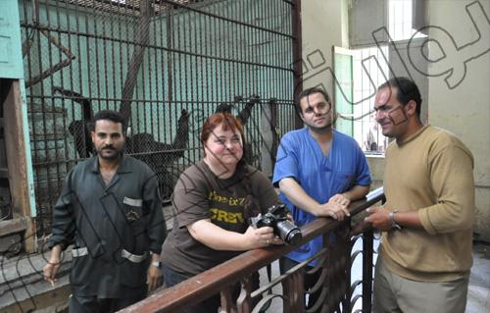
Mouza/Moza - as published by Giza Zoological Garden official website and facebook group: complete check up for Mouza/Moza at the Military Veterinary hospital عمل فحص طبي شامل ل"موزة الشمبانزي" فىالمستشفي العسكري الطبي
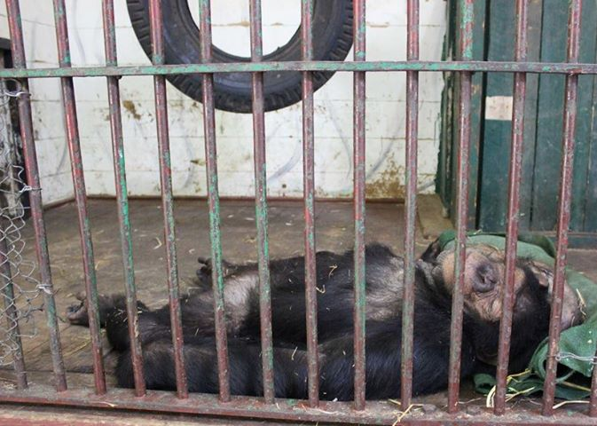
Progress and Cooperation:
What was published officially by Central Zoos and in the press:
. Surgical operation for Meshmesh by human dentist with help of veterinarians in Giza Zoo today - in the picture Wahid keeper, Hilda Tresz mentor of Jane Goodall Institute, vet Dr. Medhat , Mohamed Keeper and Dr. Mhmd Taher Mekhled, and Dr. Maha Saber Senior vet 18 June 2013, in the picture Hilda Tresz, mentor of JANE GOODALL INSTITUTE with keepers http://gate.ahram.org.eg/News/361093.aspx

. complete check up for Mouza/Moza at the Military Veterinary hospital عمل فحص طبي شامل ل"موزة الشمبانزي" فىالمستشفي العسكري الطبي
https://www.facebook.com/photo.php?fbid=590212177676733&set=a.440740985957187.98925.262242883806999&type=1&relevant_count=1
. Added by Dina Zulfikar, member of supervising committee of Central Zoos under direct supervision of Chairperson of GOVS ; some back ground about Mouza's case: Mouza was delivered to Giza Zoo April 2010, as the Giza Zoo acts as recognized rescue center of Egypt, she
had benign tumor,she
was operated on August 2010 by Dr.-Ibrahim Mohamed - Cairo Vet Faculty 2010, with zoo vets, after a while small tumor appeared under the neck and further investigations were required.
التاريخ عن حالة موزة: موزة تم نقليها الي حديقة حيوان الجيزة فى 10 ابريل 2010 لأن الحديقة تعمل كمركز انقاذ رسمي لجمهورية مصر العربية - تم عمل فحوصات و تبين اصابتها بورم حميد... اجري دكتور أبراهيم محمد - كلية طب بيطري القاهرة - جراحة ناجحة لها فى أعسطس 2010 بالاشتراك مع أطباء الحديقة - ثم ظهر بعض الورم حول الرقبة و تم استشارة اساتذة في الأورام و أخيرا كانت هناك توصيات باجراء جراحة لها و كان من المهم جدا اجراء مزيد من الفحوصات.

عملية جراحية للشمبانزى مشمش
Back to Album · ‎Giza Zoological Garden حديقة الحيوان بالجيزة‎'s Photos · ‎Giza Zoological Garden حديقة الحيوان بالجيزة‎'s Page
Previous · Next
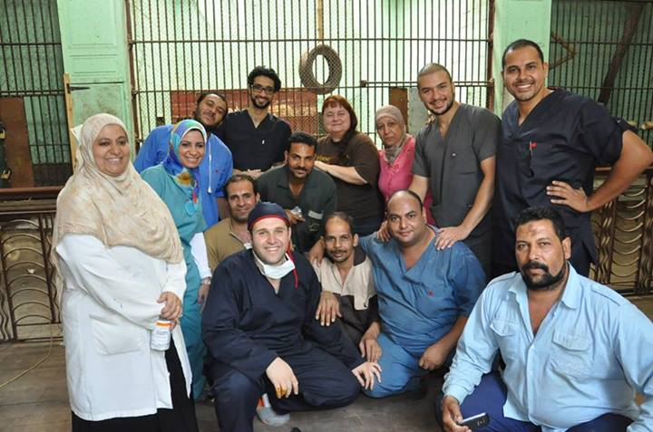
Hilda Tresz
Mhmd Taher Maklad

